February 2024
A safer rail crossing
The Thornlie-Cockburn Link is an opportunity to make crossing the rail for pedestrians and cyclists at Elliot Place/Cameron Street much safer by building a new footbridge.
Both stairs and ramps will provide access on both sides of the bridge.
Ramps will be built in a ‘switchback’ configuration parallel to the rail tracks, on the Nicholson Road / western side.

TEMPORARY LANE CLOSURE – THORNLIE

From 7 March 2024

Temporary closure of northbound lane on Cameron Street

What we are doing
- closing a road lane to support the safe construction of a drain and a footbridge
- accessing the construction site via Cameron Street cul-de-sac

When
- from 7am, Thursday 7 March 2024

Where
- Cameron Street on the Tom Bateman Wetlands side, around 150m from the cul-de-sac

What to expect
- temporary partial road closure on Cameron Street. Refer to sketch overleaf
- access to properties will be maintained
- traffic management
- all works will follow approved noise and traffic management plans
- the area will be reinstated at the end of the project

24-hours contact
- METRONET on 9326 3666

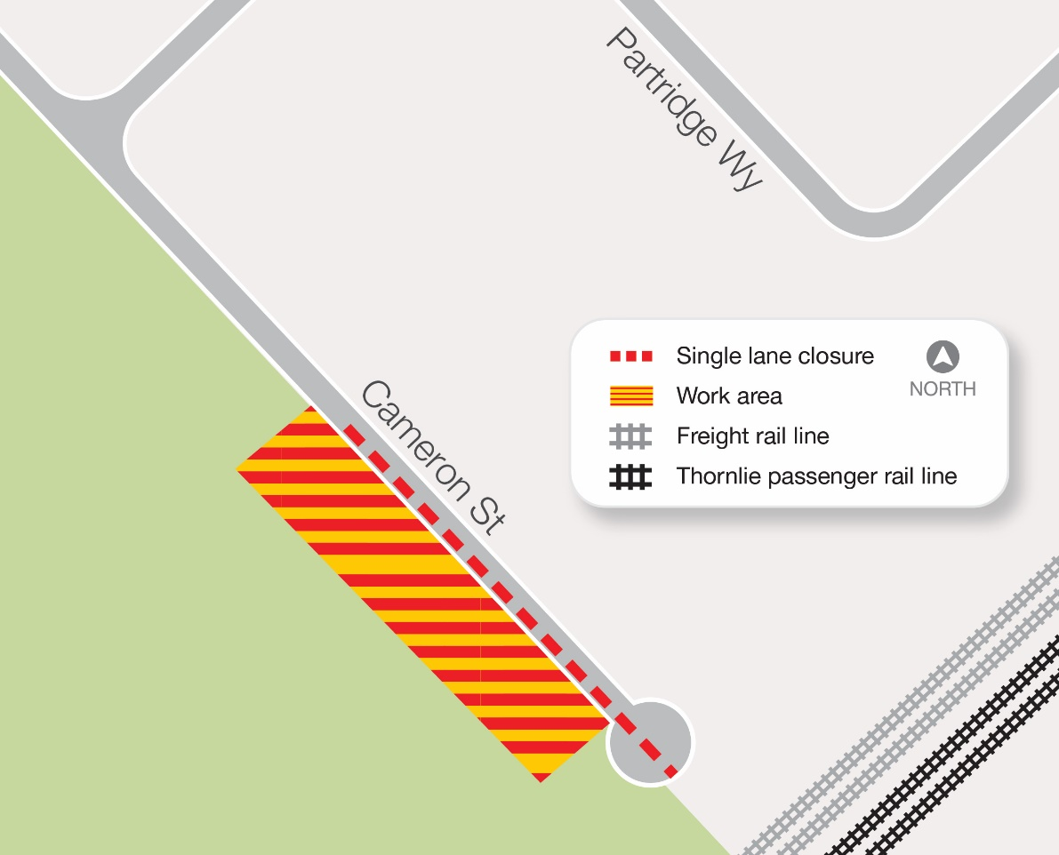
Sketch of the temporary partial road closure

